ASSIGNMENT object and class

1. Create a class person which has member variables as Name, Age, and

Address. There are two member functions in this class showData ( ),

getData ( ), though which one can collect the information and show it to user.

#include<iostream>

#include<string>

using namespace std;

class person

{

private:

string Name;

int Age;

string Address;

public:

void getData()

{

cout<<"Name of person :"<<endl;

cin>>Name;

cout<<"Age of person :"<<endl;

cin>>Age;

cout<<"Address of person :"<<endl;

cin>>Address;

cout<<endl;

}

void showData()

{

cout<<"Name :"<<Name<<endl;

cout<<"Age :"<<Age<<endl;

cout<<"Address :"<<Address<<endl;

cout<<endl;

}

};

int main()

{

person p1,p2,p3;

p1.getData();

p1.showData();

p2.getData();

p2.showData();

p3.getData();

p3.showData();

return 0;

}

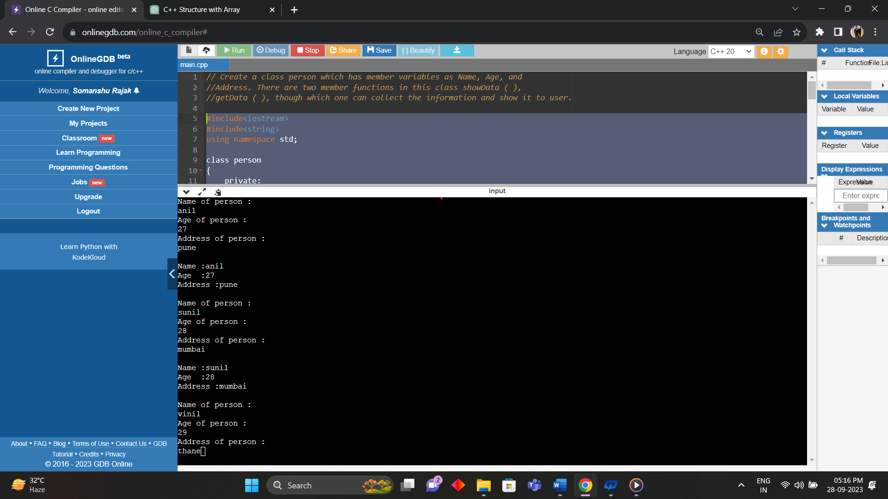

2. Create a class, Employee which has empno, rank, department, salary as

member data, and get and show as member functions.

#include<iostream>

using namespace std;

class Employee

{

private:

int empno;

double rank;

string department;

double salary;

public:

Employee();

void show();

};

Employee::Employee()

{

cout<<"Employee number :"<<endl;

cin>>empno;

cout<<"Rank :"<<endl;

cin>>rank;

cout<<"department name :"<<endl;

cin>>department;

cout<<"salary in ruppes:"<<endl;

cin>>salary;

cout<<endl;

}

void Employee::show()

{

cout<<"Employee number :"<<empno<<endl;

cout<<"Rank :"<<rank<<endl;

cout<<"department name :"<<department<<endl;

cout<<"salary in ruppes:"<<salary;

cout<<endl;

}

int main()

{

Employee E1,E2,E3;

E1.show();

cout<<endl;

E2.show();

cout<<endl;

E3.show();

cout<<endl;

return 0;

}

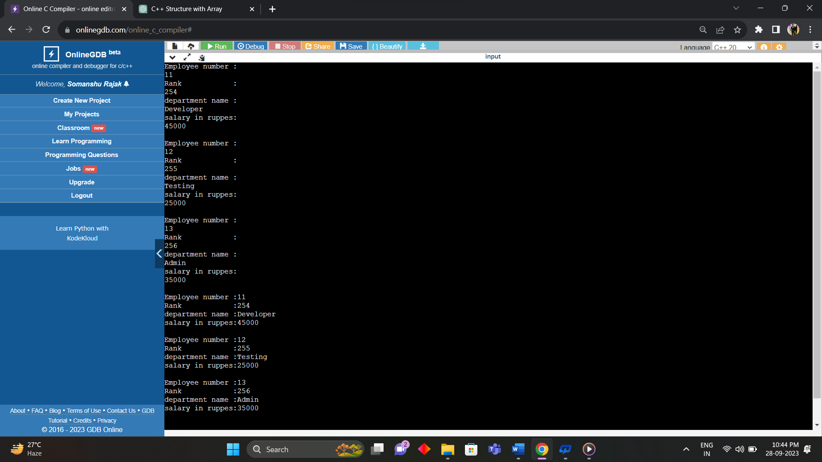

3. Write a program to swap two numbers using reference variable.l:::??

#include <iostream>

using namespace std;

class A

{

private: // access spiecifier

int a,b;

public:

A(int ,int );

void show();

};

A::A(int x,int y)

{

a=x,b=y;

cout<<"Before swapping :"<<a<<","<<b<<endl;

a=a+b;

b=a-b;

a=a-b;

}

void A::show()

{

cout<<"After Swapping :"<<a<<" "<<b<<endl;

}

int main()

{

A obj(10,20);

obj.show();

}

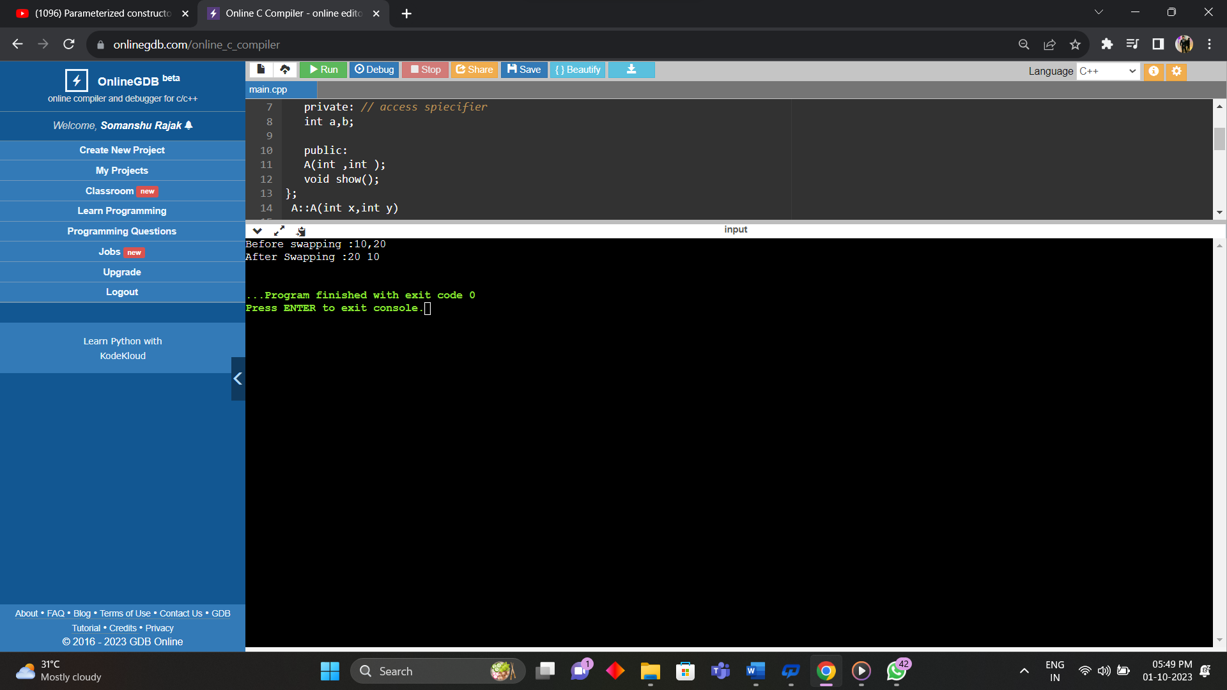

4. Create a class student with admno, name, marks whose functionality is

to calculate the marks obtained by the student.

#include<iostream>

using namespace std;

class Student

{

private:

int admno;

string name;

int marks;

float perc;

public:

Student();

void show();

};

Student::Student()

{

cout<<"Admission number :"<<endl;

cin>>admno;

cout<<"Student name :"<<endl;

cin>>name;

cout<<"Enter total marks outof 500 :"<<endl;

cin>>marks;

perc = (float)marks / 500 * 100;

cout<<endl;

}

void Student::show()

{

cout<<"Admission number :"<<admno<<endl;

cout<<"Student name :"<<name<<endl;

cout<<"total marks outof 500 :"<<marks<<endl;

cout<<"Percentage obtained :"<<perc<<endl;

cout<<endl;

}

int main()

{

Student S1,S2,S3;

S1.show();

cout<<endl;

S2.show();

cout<<endl;

S3.show();

cout<<endl;

return 0;

}

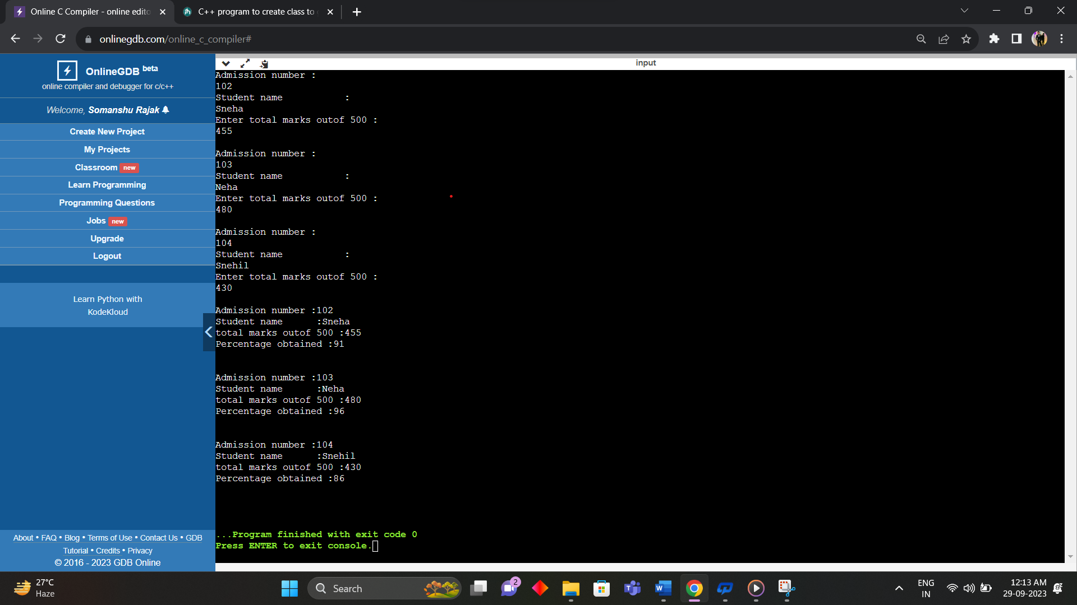

5. Create a bank account class containing account number, name and

current balance whose functionality is to deposit and withdraw the

amount for corresponding customer.

#include<iostream>

using namespace std;

class Bank

{

private:

int accno;

string name;

float current_bal;

public:

void deposit();

void withdraw();

void display();

};

void Bank::deposit()

{

int deposit_amount=25000;

cout<<"Account number :"<<endl;

cin>>accno;

cout<<"Account holdername :"<<endl;

cin>>name;

cout<<"current balance :"<<endl;

cin>>current_bal;

current_bal+=deposit_amount;

cout<<endl;

cout<<"Bank details"<<endl;

}

void Bank::withdraw()

{

int withdraw_amount=20000;

cout<<"Account number :"<<endl;

cin>>accno;

cout<<"Account holdername :"<<endl;

cin>>name;

cout<<"current balance :"<<endl;

cin>>current_bal;

current_bal-=withdraw_amount;

cout<<endl;

cout<<"Bank details"<<endl;

}

void Bank::display()

{

cout<<"Account number :"<<accno<<endl;

cout<<"Account holdername :"<<name<<endl;

cout<<"current balance :"<<current_bal<<endl;

cout<<endl;

}

int main()

{

Bank B1,B2;

B1.deposit();

B1.display();

cout<<endl;

B2.withdraw();

B2.display();

cout<<endl;

return 0;

}

